What is batch processing and when need to go for batch processing?
Which is used to process bulk or large amount of data at a time
Real world example:
banking field:
‘A’ bank will get the all the transactions from their data base and process at a time into ‘B’ bank
Ecommerce/Retail:
Every day update the 10000 of records in the form of CSV. Store the all data from the CSV to Data base in single shot

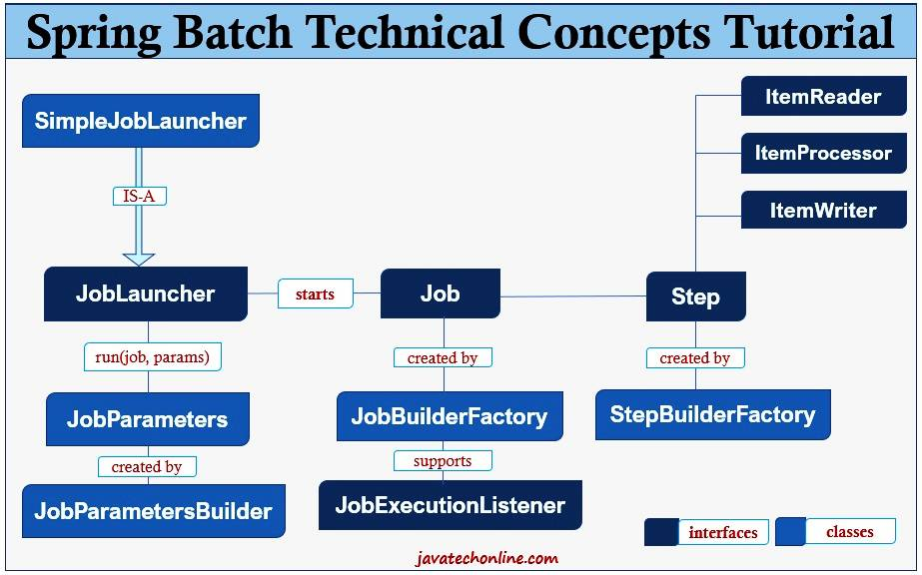

What is spring batch?
- It is light weight batch framework based on spring
- Used for high volume batch processing
- It provides various I/O options like JSON, XML, SQL databases etc.
- Options: start, stop and restart
- Retry and skip mechanism

For processing data from CSV to Database no need to write the code from scratch for reading and wring
Instead, only we need to give the column structure into Spring Batch

What is Job and step?
In spring batch, each Job can have multiple steps
Example:
Transaction (Job) -> Communicate with another Bank (Step)
-> Debit money (Step)
-> Send SMS/Email (Step)
Steps Types:
- Tasklet Step
Transaction (Job) -> Communicate with another Bank (Step)
-> Debit money (Step)
-> Send SMS/Email (Step)
- Chunk- Oriented Step
ItemReader, ItemProcessor and ItemWriter
Every day update the 10000 of records in the form of CSV. Store the all data from the CSV to Data base in single shot
